- Install git.

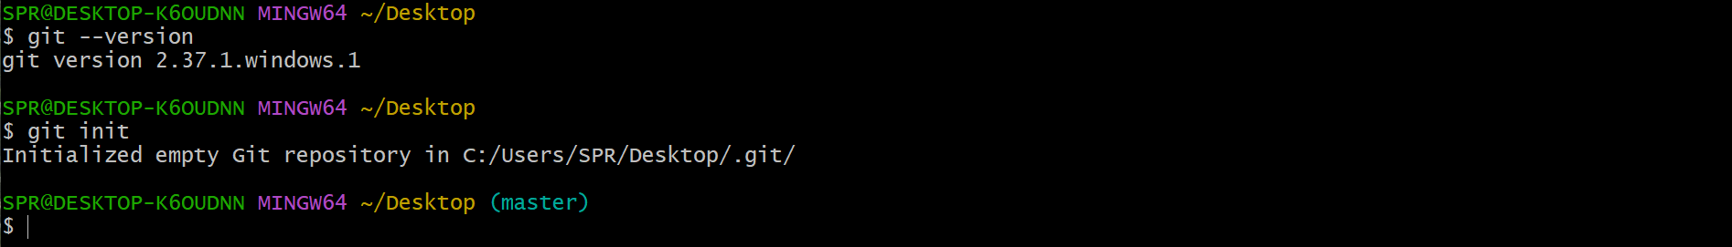

- Create a repo in github with README.md and .ignore file.

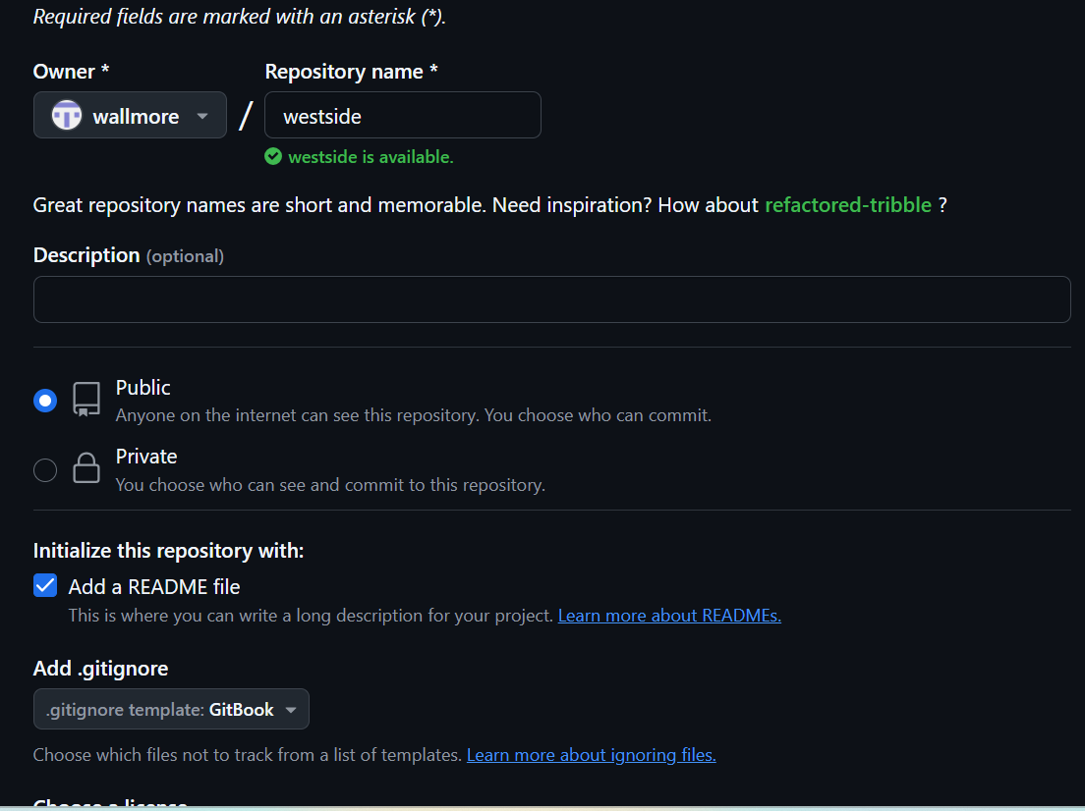

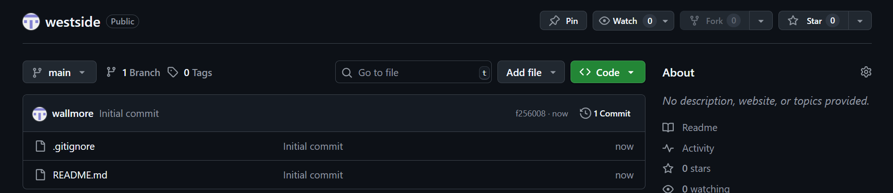

- Clone the created repo to local.

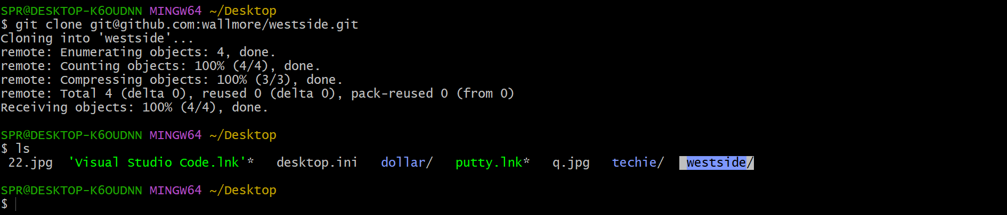

- Create two files in local repo.

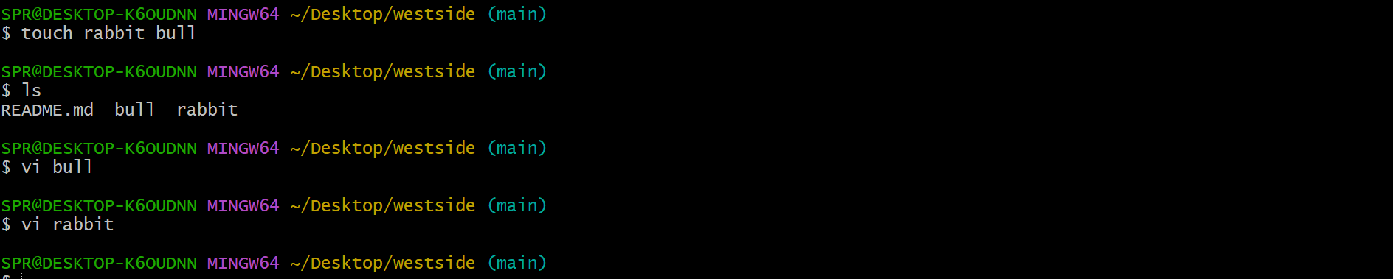

- Commit two files and push to central Repository.

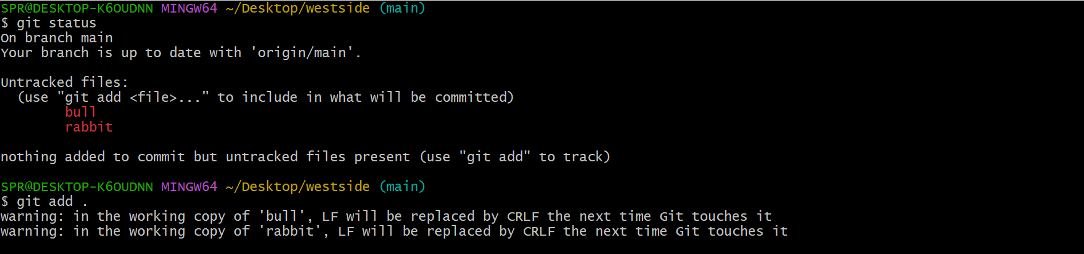
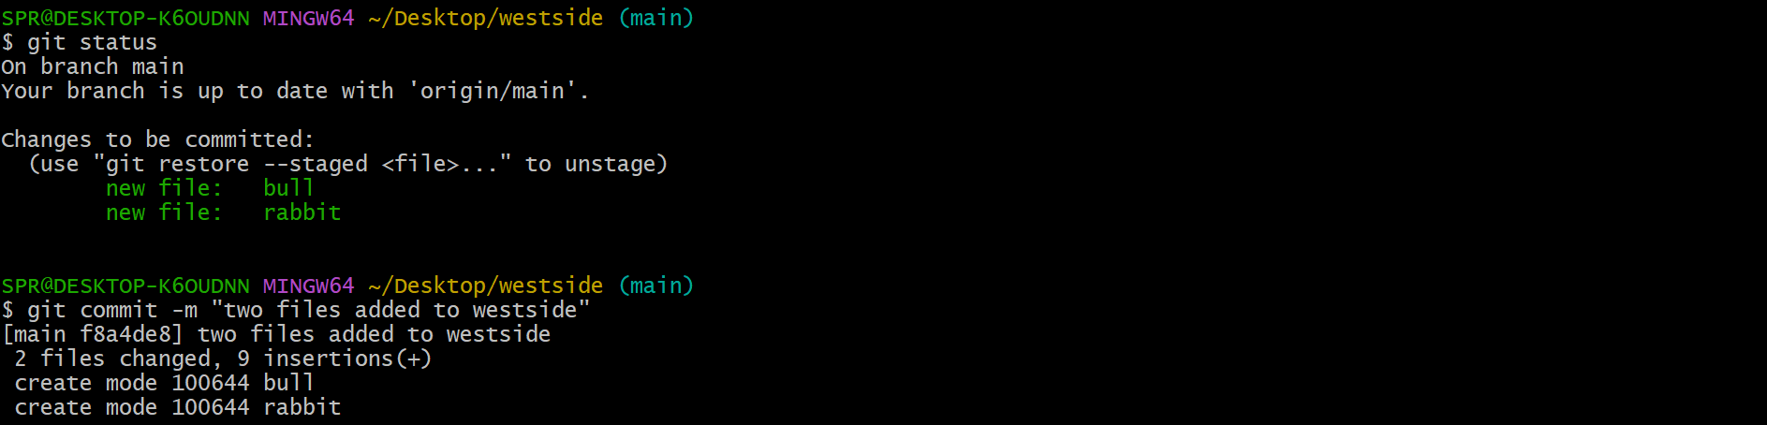
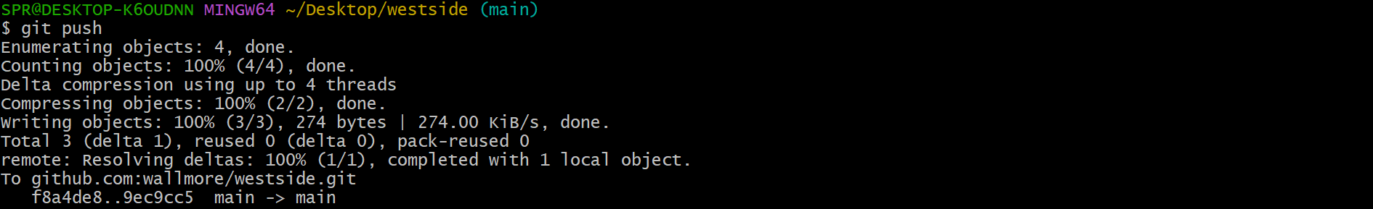

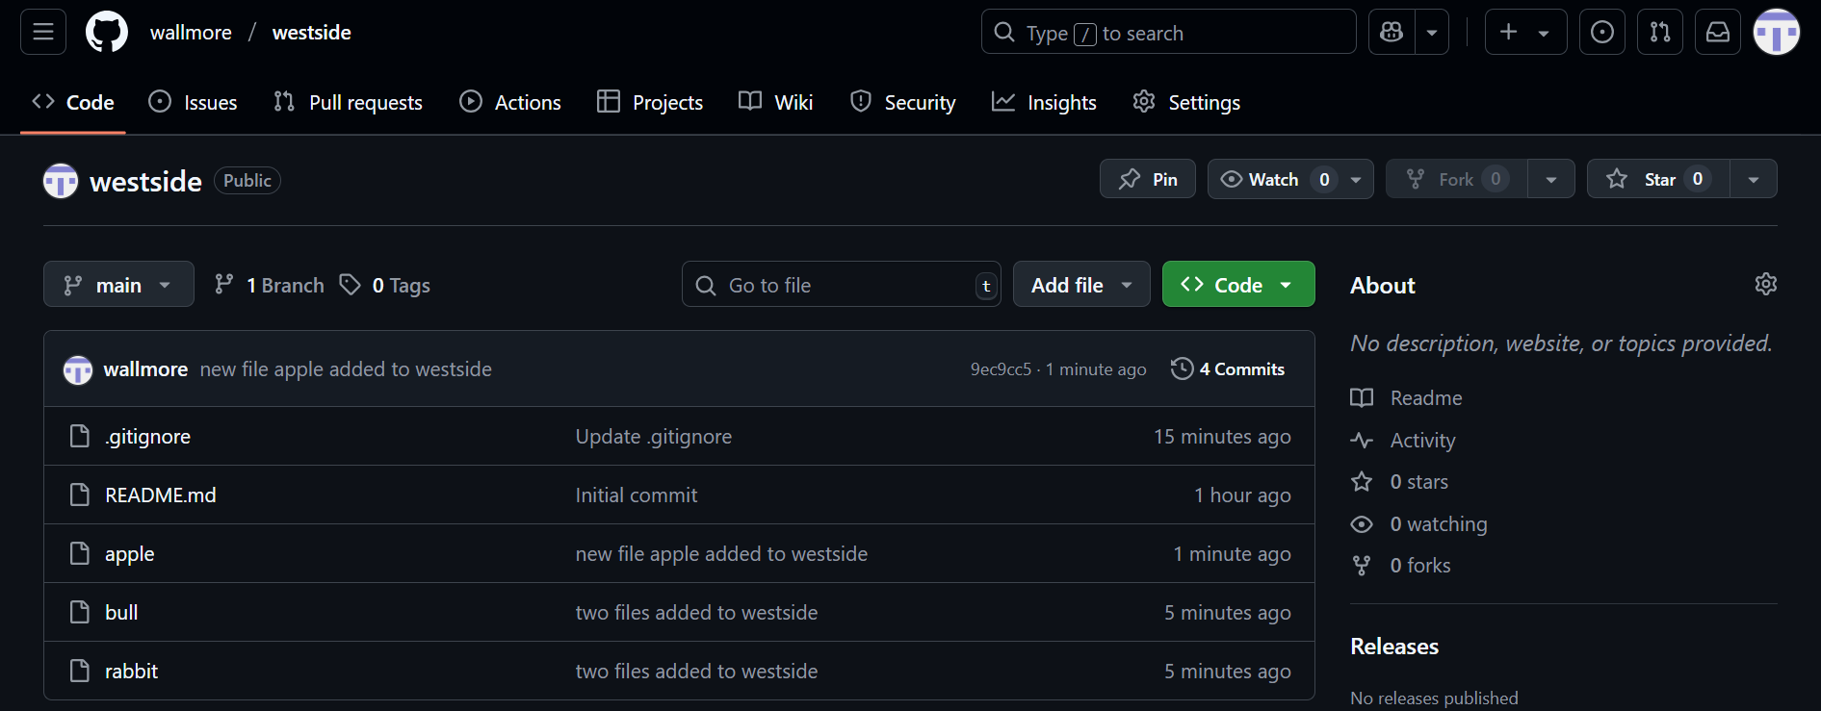

- Create a branch in local and create a sample file and push to central.

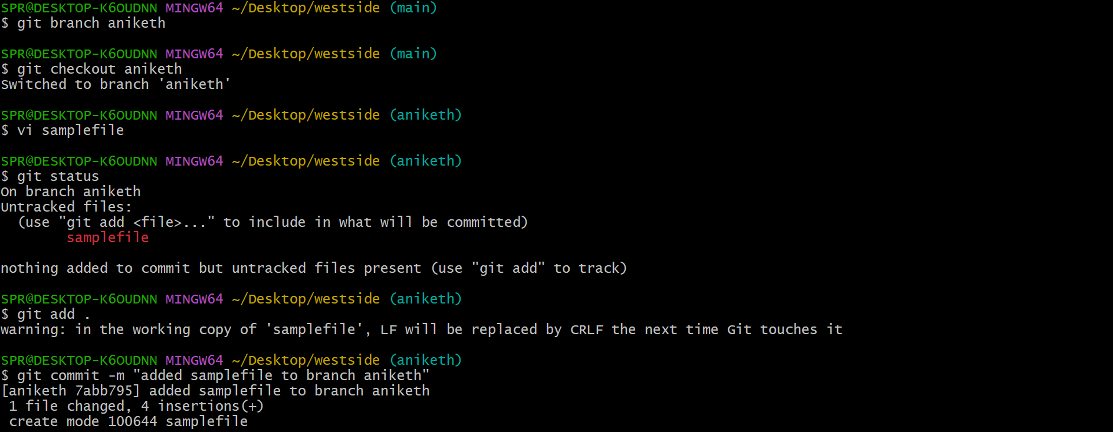
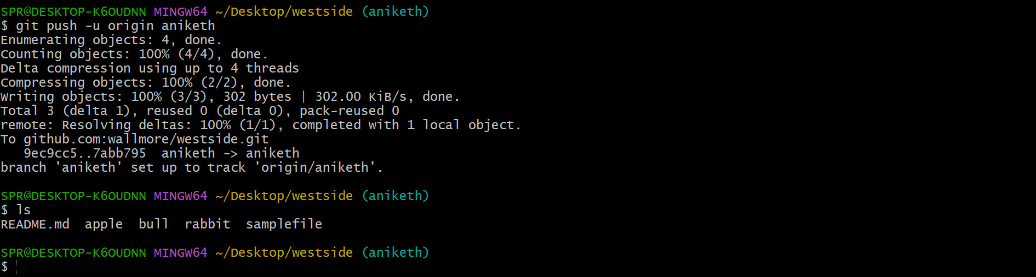

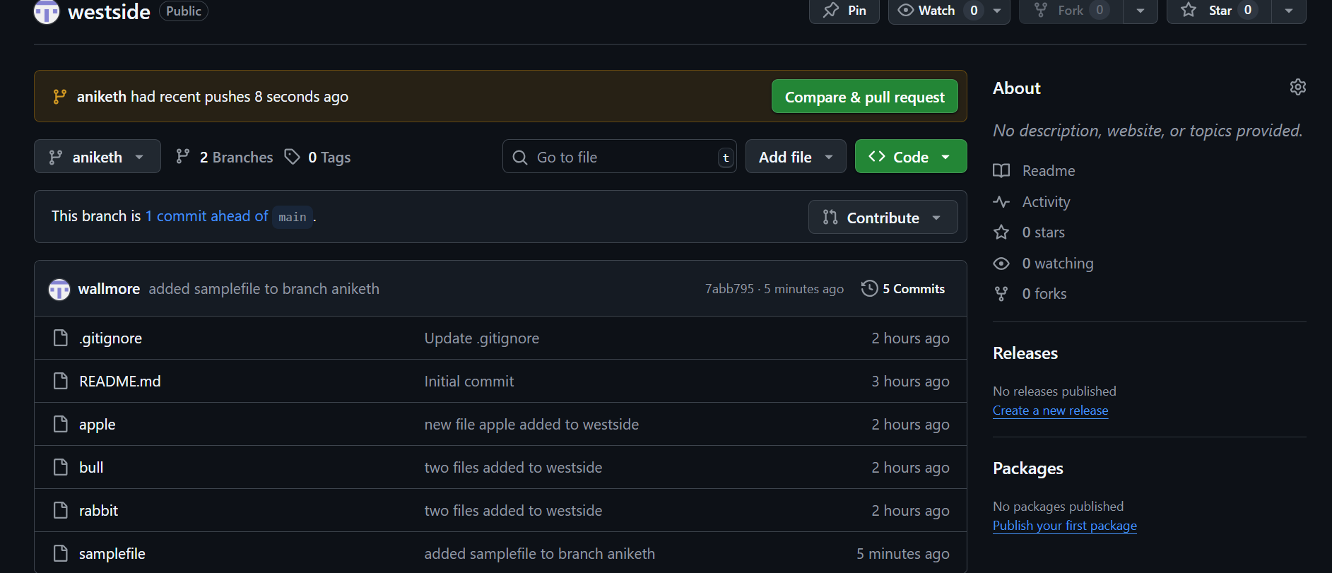

- Create a branch in github and clone that to local.
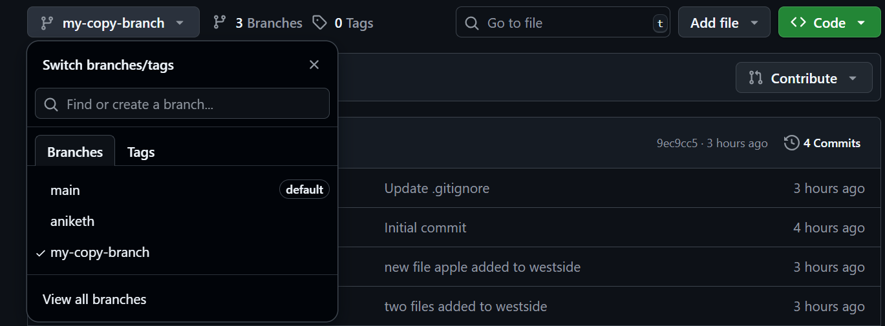

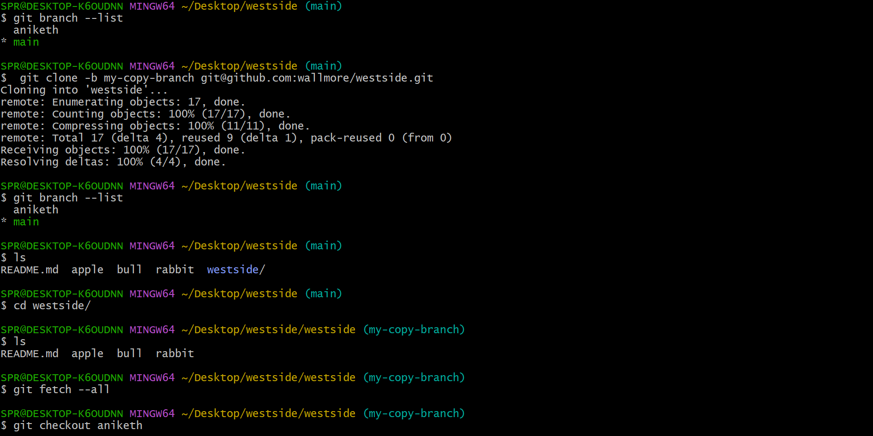

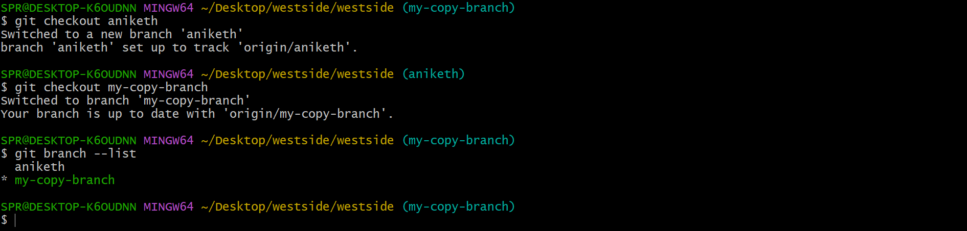

- Merge the created branch with master in git local.

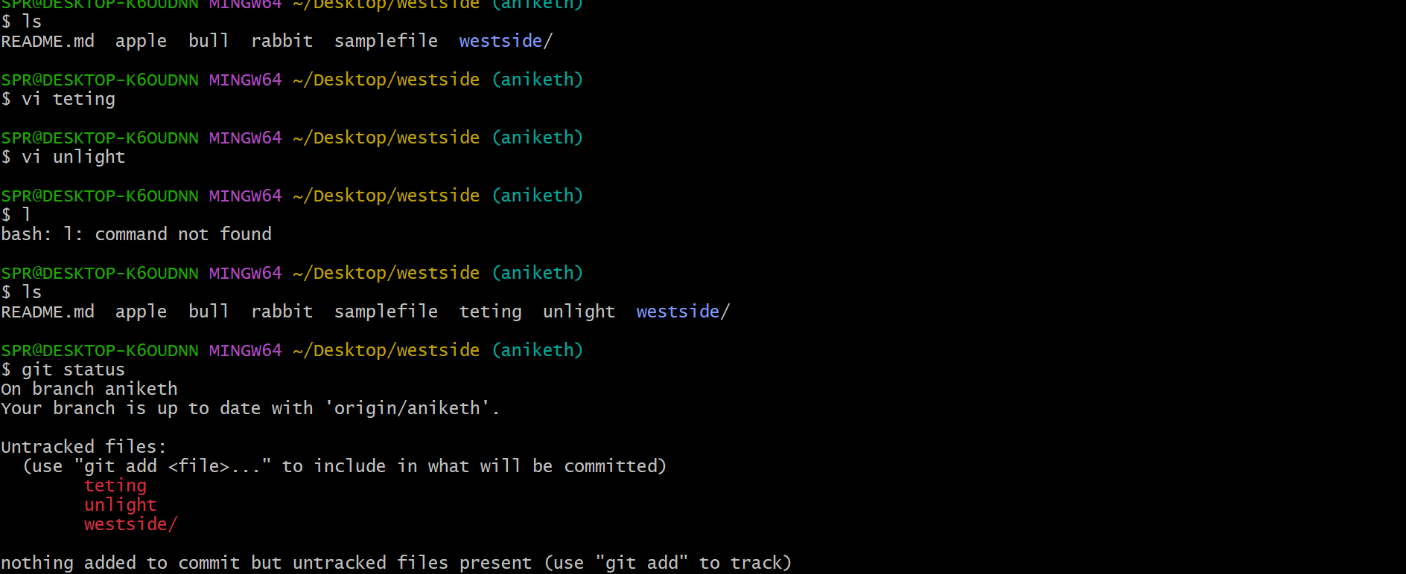

- Merge the created branch with master in github by sending a pull request.
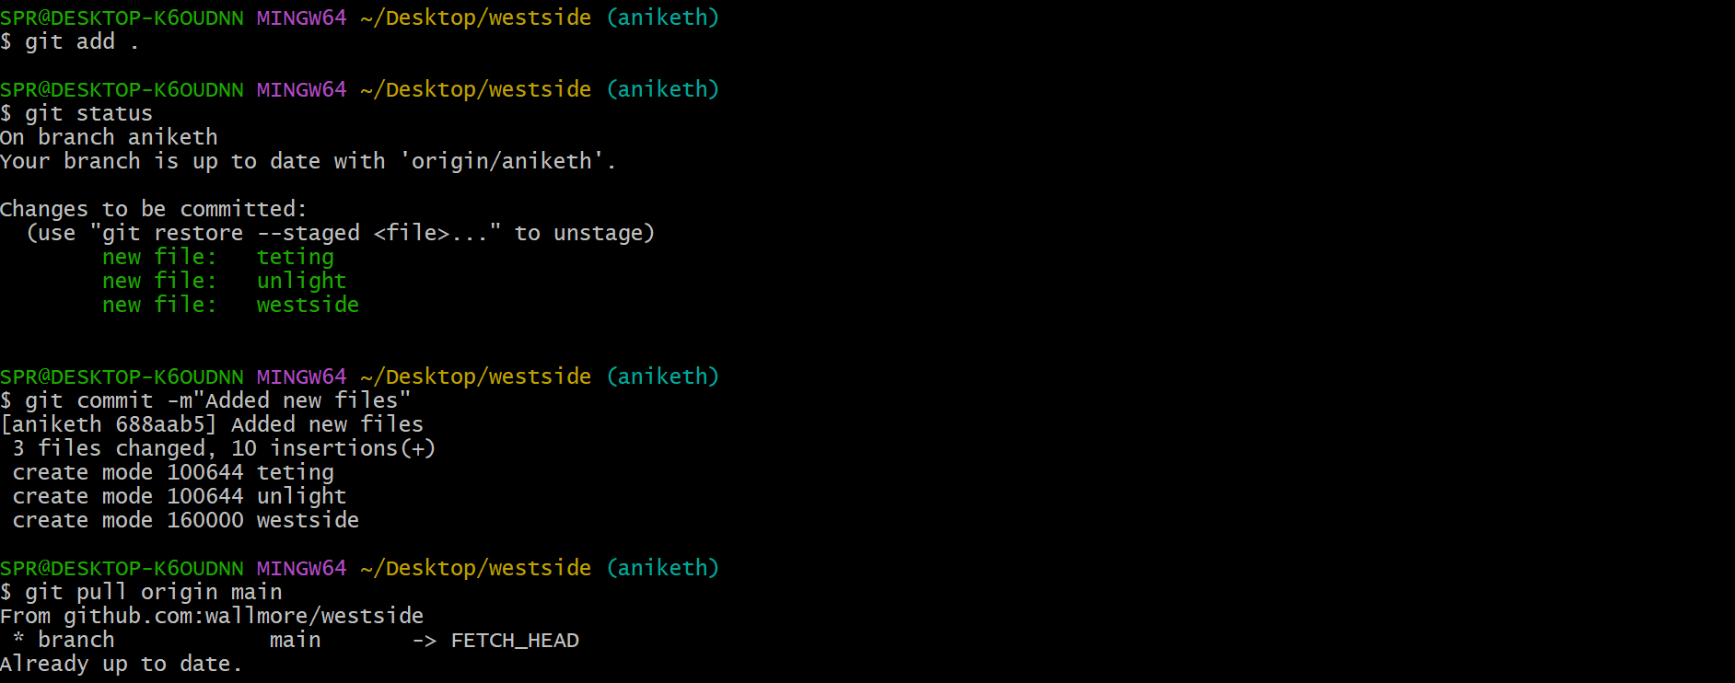

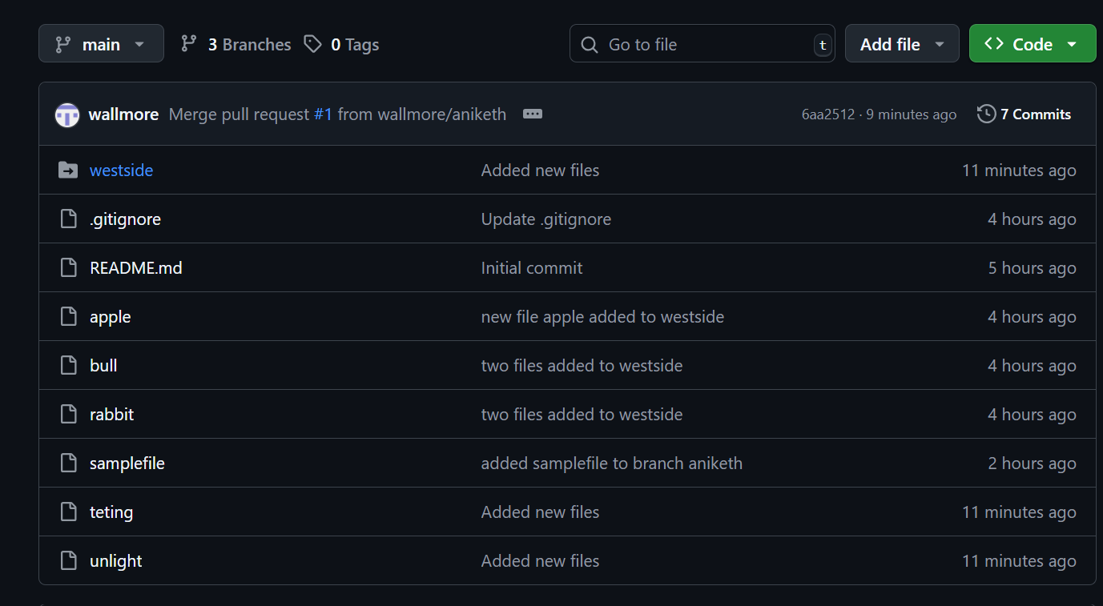

- create a file in local and send that to branch in github.

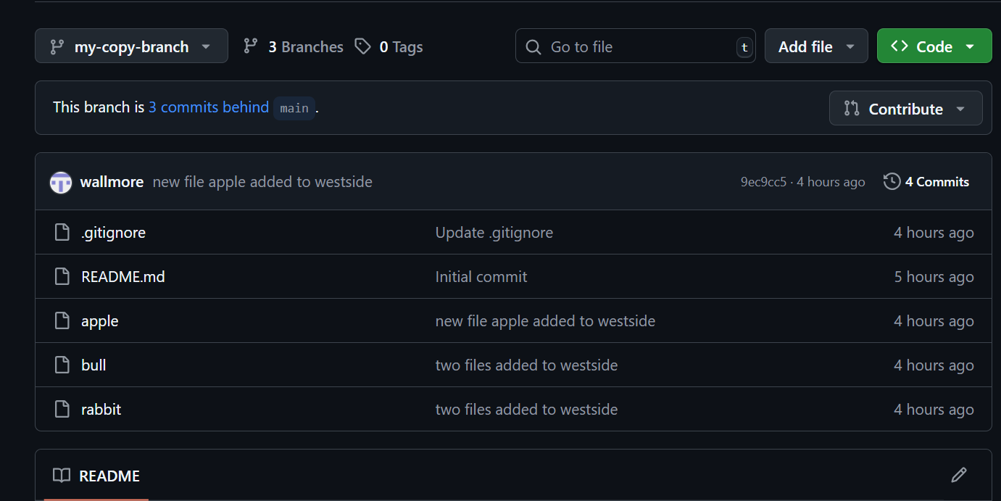

- clone only a branch from github to local.

- create a file with all passwords and make that untrackable with git.

- make a commit and make that commit reset without savings changes.

- Revert a commited commit to the older version.

- push a file to stash without savings the changes and work on another file.

- undo the stash file and start working on that again.

- generate a ssh-keygen and configure into github.
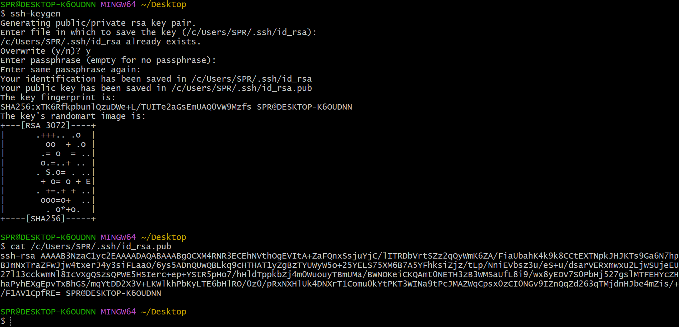
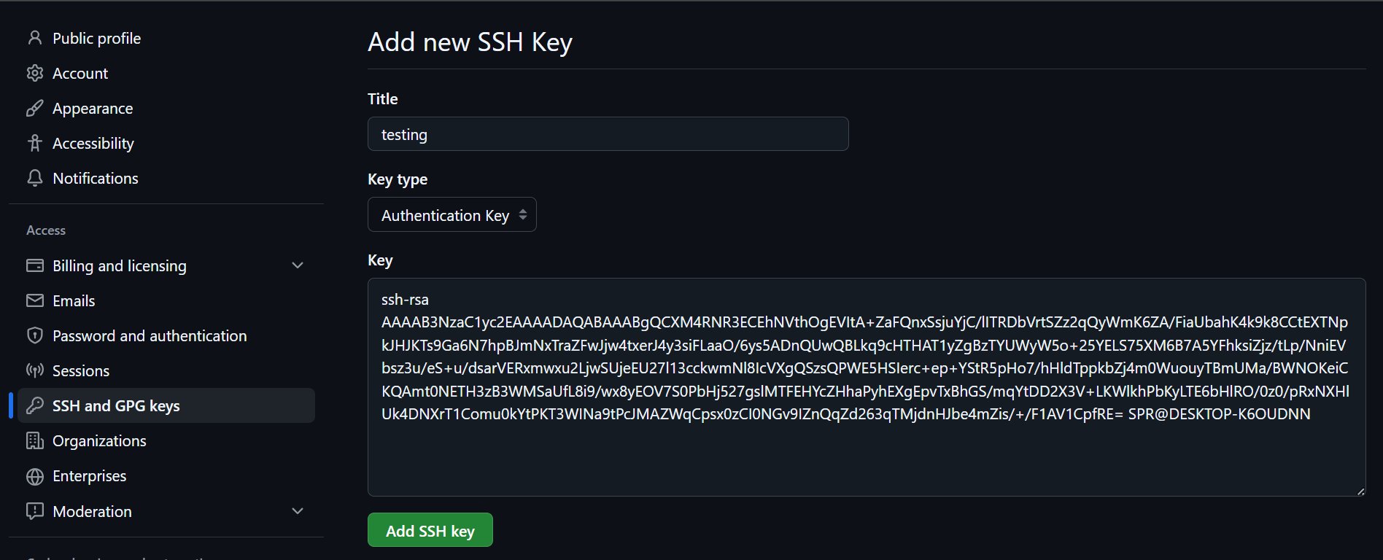

- configure webhooks to github.

- basic understanding of .git file.

- Check all the logs of git.

- Rename the commit message.

22)Merge multiple commits into single commit.

